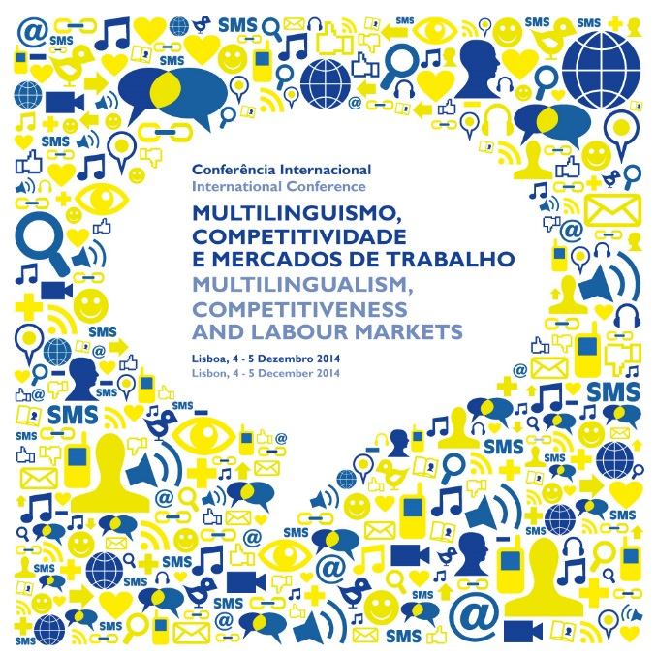
REGISTRATION
Please, send to:
Email: teresa.moncada@erasmusmais.pt / Sandra.bras@erasmusmais.pt

I will attend to the Conference on Thursday, Dec. 4, 2014: Yes No
I will attend to the Conference on Friday, Dec. 5, 2014: Yes No

Name:

Company/Organisation:

Address:

Country:

Position:

Phone:

Email:

