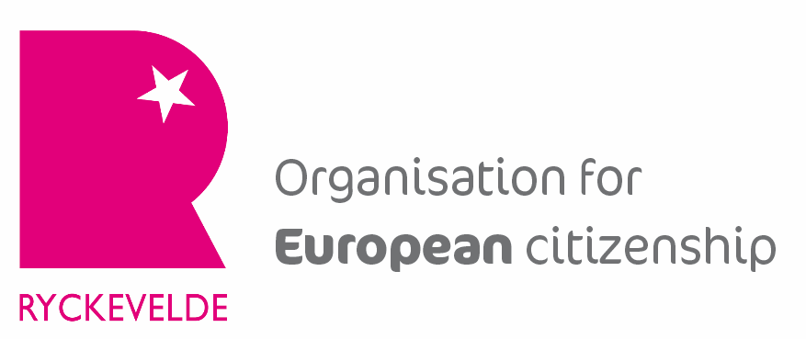 | 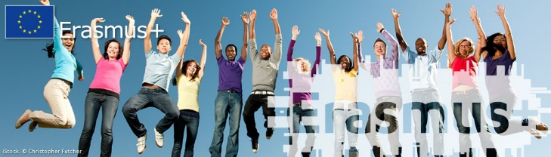 | 

Eramus+ Contact seminar
on Early Childhood Education and Care

Title | Contact seminar ‘Early Childhood Education and Care’
Practical information | Date | 26-30 November 2014
Practical information | Venue | Bruges, Belgium
Practical information | Target group | Organisations aiming to realise a KA2-partnership in school education on Early Childhood Education and Care (ECEC), such as pre-primary schools, childcare, etc.
Practical information | Group size | 45 participants
Content | Epos vzw organises a Contact seminar on ‘Early Childhood Education and Care for 45 participants coming from schools or organisations aiming to do a KA2 partnership in school education.  Participants will receive information about the Erasmus+ programme in general and about KA2 in detail, how to fill in the application form, good practices, etc.  Participants get all necessary support to find partners, to work out concrete project ideas and to prepare the project application.  The Contact seminar will take place from 26 to 30 November 2014 in Bruges, Belgium.  Participation to the seminar costs 700 EUR (to be confirmed; might be 650 EUR)  Detailed programme: cf. below
Registration | Deadline for registration: 1/11/2014  (procedure: to be decided)  After registration the participants receive more detailed practical information.

Programme

Wednesday 26 November

18h45 All participants gather at the reception desk of the hotel
(Hotel Ibis/Novotel, Katelijnestraat 65)
19h00 Dinner at hotel ‘Novotel’
20h00 Opening ceremony of the contact seminar: introduction to the conference and icebreaking performance by Inspinazie
20h45 Informal drink

Thursday 27 November

09h00 All participants gather at the reception desk of the hotel (Ibis)
09h15 Welcome
(Hotel Novotel, Katelijnestraat 65)
09h25 Information about the ERA+ programme – Wim Cloots, Epos vzw
10h05 Information about the EU policy view on Early Childhood Education and Care – European Commission
10h35 Overview of KA2 do’s and don’ts – Inés Verplancke, Ryckevelde vzw
11h00 Coffee break
11h30 Good practice examples of projects on ECEC:
- “Early Years and Equality. Observing and living each other's practice in Early Years to inform quality development.” – Gert Nielandt, stad Antwerpen or Veerle De Troyer, GO!
- “Once upon a technology” – Gemeentelijke kleuterschool Antwerpen, Kathy Mertens
12h20 Information about the afternoon programme
12h30 Lunch at Novotel
13h30 Start of the workshops: workshop session 1
Workshop 1: ICT for toddlers, Jens Vermeersch, Go!
Workshop 2: Early language learning, Iris Bruneel, pedagogical adviser (pre-) primary schools
Workshop 3: Technology and science for toddlers, Leen De Bie, stad Gent
15h00 Break
15h30 Workshop session 2
17h00 Break
18h00 Fair + sandwiches
19h30 End of the School fair

Friday 28 November

09h00 All participants gather at the reception desk of the hotel
09h05 Group Picture
09h15 Lecture: Filling out the KA2 application forms – Inés Verplancke, Ryckevelde vzw
(Hotel Novotel, Katelijnestraat 65)
10h50 Coffee break
11h10 Partner finding session
12h10 Lunch
13h30 Guided tour in Bruges
(Point of departure: entrance of hotel Ibis)
15h00 Free time
19h15 All participants gather at the reception desk of the hotel
19h30 Visit to the brewery ‘De Halve Maan’
(De Halve Maan, Walplein 26)
20h00 Dinner

Saturday 29 November

09h00 All participants gather at the reception desk of the hotel
09h15 Introduction
(Hotel Novotel, Katelijnestraat 65)
09h30 Filling in the application form of KA2-projects
12h30 Lunch
13h30 Filling in the application form of KA2-projects
17h30 Plenary presentation of projects
18h30 Farewell dinner

Sunday 30 November

Departure

