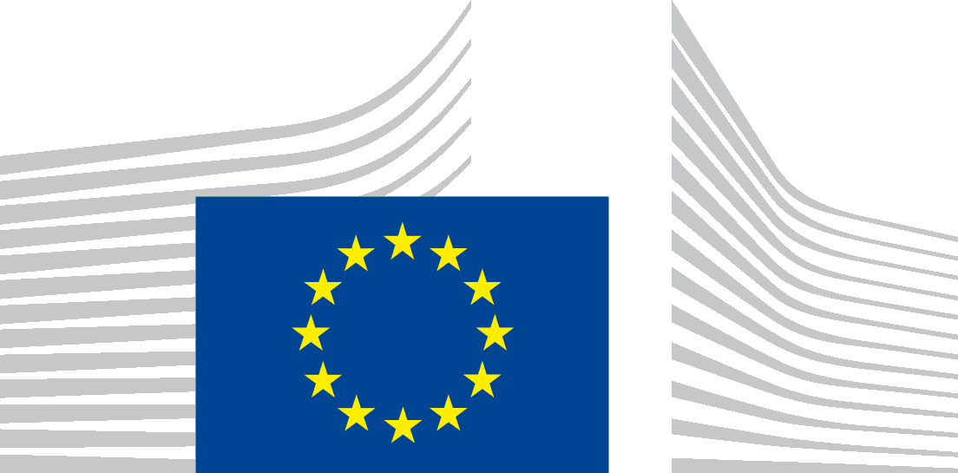 | Research Executive Agency  A4 Marie Skłodowska-Curie COFUND, Researchers' Night and Individual Fellowships: Global

EUROPEAN RESEARCHERS' NIGHT 2018-2019
CALL H2020-MSCA-NIGHT-2018
INFORMATION DAY, 14 DECEMBER 2017, COVENT GARDEN, 16, PLACE ROGIER B 1049 BRUSSELS,
AGENDA
MEETING ROOM COVE A2/4/121
- 9.30- 9.45: Policy changes introduced in the 2018-2020 Work Programme, Manuel LAPORTA GRAU, Assistant Policy Officer, DG EAC
- 9.45- 10.15: Reminder: Main features of the European Researchers' Night
- 10.15- 10.45: Coffee break
- 10.45- 11.15: Tips and tricks for a successful proposal
- 11.15-12.30: Information and questions:
- Award criteria
- Eligible costs
- Filling in the proposal (Parts A and B)
- Any other issue of interest linked to the topic

