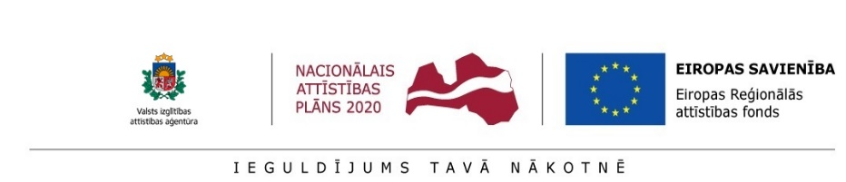
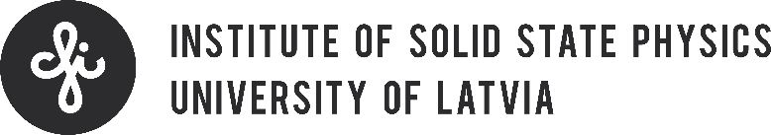

Save the Date
Brokerage Event: H2020, FP9 and Nordic-Baltic Network
Riga, Latvia, June 6th 2018

We are glad to announce that the Institute of Solid State Physics, University of Latvia (ISSP UL) and State Education Development Agency`s (SEDA) Horizon 2020 National Contact Point will organize a brokerage event on Horizon 2020, FP9 and Nordic-Baltic Network possibilities in 2nd floor conference hall in ISSP UL, 8 Kengaraga street, Riga, on June 6th.
Don`t miss this opportunity and get involved!
Why participate?
- Get information on Horizon2020 opportunities for public and private sectors, ICT, SME and applied research perspectives and opportunities to recruit qualified personnel using PostDoc Latvia project;
- Find out what to expect from FP9;
- Get introduced to UK Science and Innovation Nordic-Baltic network and possibilities to form bilateral R&D relationships between UK and Latvian institutions;
- Meet potential partners from other sectors.
Target audience: entrepreneurs, scientists, organizations, networks
Participation to the brokerage event is free of charge!

The registration will open on May 23rd.

